GET239 - Enterprise Technologies Lecture Notes

The Internal Operating System Weeks 11 & 12

Last Time
Last time, we took a broad look at different types of facilities that are provided as an interface for the user and for the user's programs. We examined both the services provided by the operating system and the nature of the user interface that delivers those services. We included in our discussions the following ideas and concepts:
- The features and strengths of the various types of user interfaces, and the tradeoffs between them
- The nature of the different types of tasks and services that are performed within a user interface
- The purpose and design of command languages and shell scripts.
- The purpose for the job control language or JCL
- The services that are provided to a user's programs; the concept of an application programming interface

Over the years operating systems have been engineered to provide a variety of very powerful services that allow the user to effectively manage their computing resources. They have attempted to provide ease of access to these resources through a number of interfaces for both the user and the user’s programs. These interfaces have become the user’s gateway to both interactive and batch capabilities. Modern operating systems have come a long way in providing the convenience and ease of use that many users need and want.

This week we are going to continue our operating system journey by further exploring the internal mechanisms that makeup the modern operating system. You will see that these mechanisms provide the services that perform resource management duties that make today’s computer systems powerful work horses for solving large-scale business problems.
-----------------------------------------------------------------------------------------------------------

1. Major Ideas and Concepts
Let’s take a closer look at the internal services that an operating system provides. These services are almost always invisible to the computer user, that is, until something goes wrong. It is these services that give the operating system the capability to manage the system resources of memory, files, devices and networks in such a way that a computer is able to process many large units of work without any one user realizing that these services are being shared among many other users. It is not unusual for a single large computer to support thousands of users concurrently. We’ll include in our discussions the following ideas and concepts:

- The concept of processes and threads; process and thread creation, process management, process states, and thread manipulation
- Techniques used for scheduling and dispatching processes and threads; system dispatching objectives and criteria for evaluation; dispatch algorithms for non-preemptive and preemptive multitasking systems
- Memory management techniques; memory partitioning, the concept of overlays; fragmentation issues
- The role of the operating system in the operation and management of virtual storage; page faults; working sets; page sharing; page replacement algorithms, the prevention of thrashing
- Algorithms for scheduling efficient use of secondary storage devices
- Networking OS services, protocol stacks, sockets, remote procedure calls, and other system services
- The concept of deadlock
- The concept of a virtual machine

2. Introduction to Operating System Internals
The easiest way to become familiar with the internal services of the operating system is to view an operating system model. Englander’s model below illustrates that the operating system services are contained in a set of logical layers.
User or program requests.

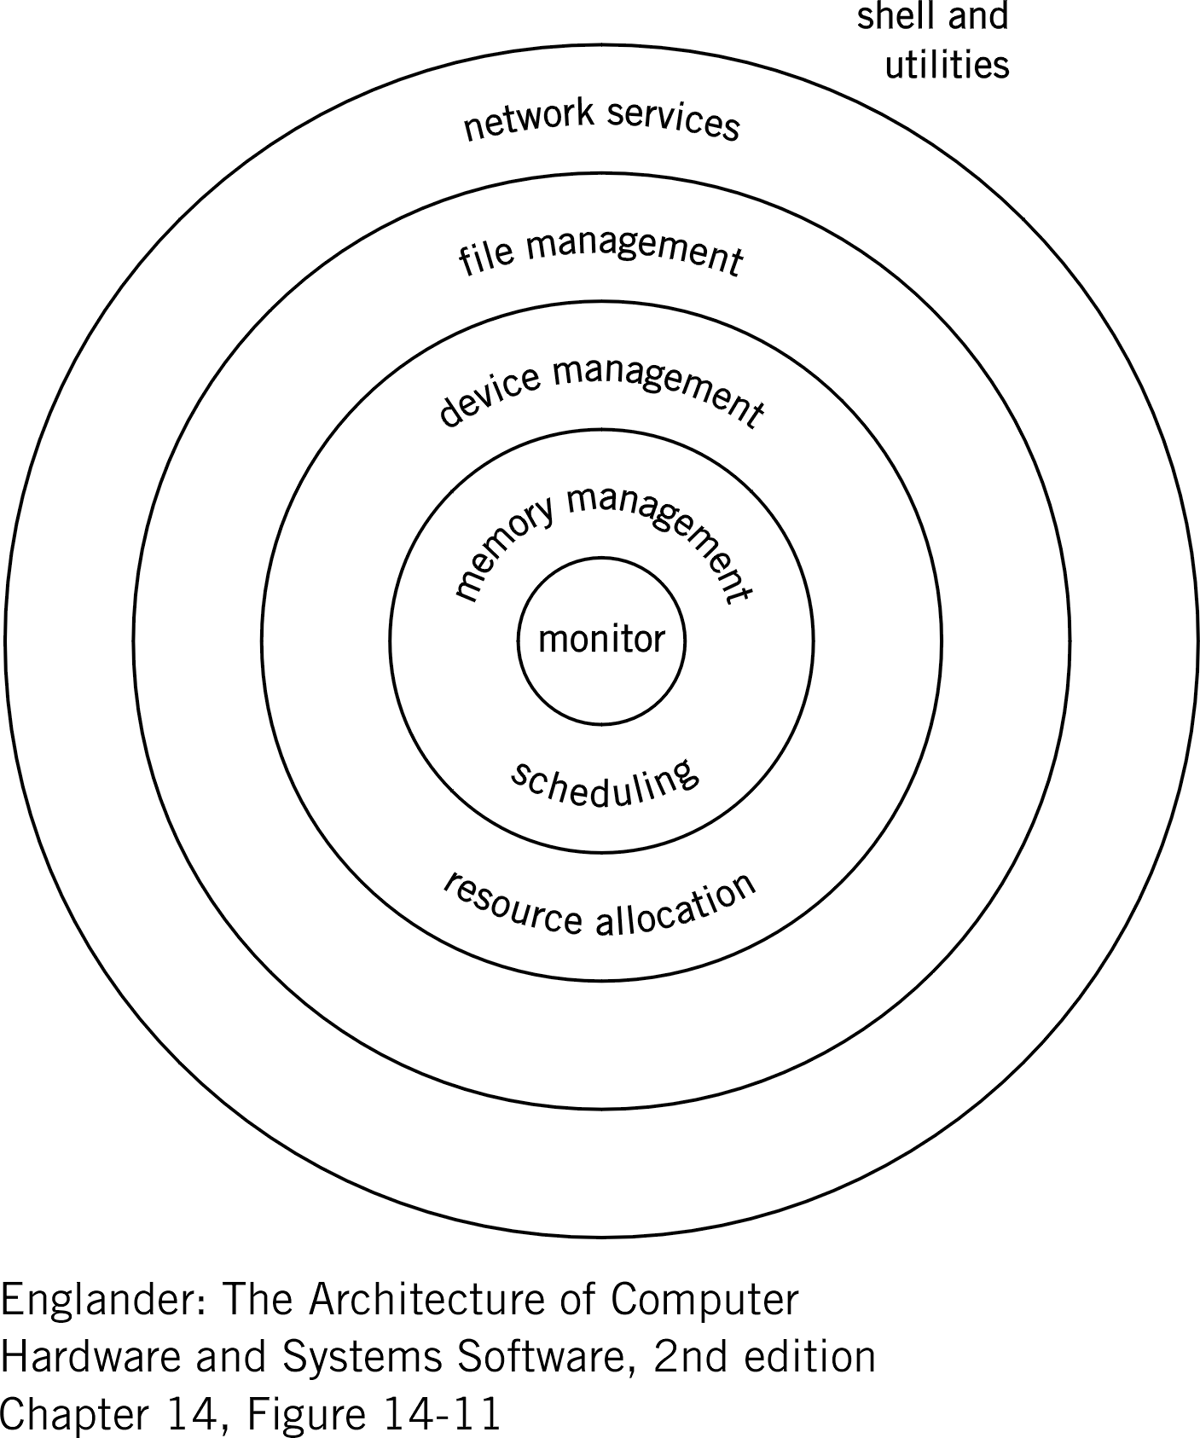
Determines if it’s possible to load programs or data.
Device and program conflicts are resolved here.
Provides overall control, manages conflicts and handles errors
Provides transmission protocols and data transmission formats
Logical file requests are translated to physical I/O requests.

Also this model provides a level of security to the operating system since services from any given layer can only be requested by using special hardware protected instructions that can only be interpreted from the closest layer.

Let’s take a look at how these services work, starting with units of work called processes and threads.

3. Processes and Threads
As we think out what a multi-user, multitasking operating system does, we discover that the operating system ultimately only acts on computer instructions (like the Little Man Computer) in the form of computer programs. This is also true for commands entered through a graphic user interface. Since these keyboard commands and mouse clicks are shortcut mechanisms for invoking or launching a program. Let’s examine how the operating system interprets and acts on these programs.

Processes
A process is a computer program, which is software, along with all the computing resources (memory, I/O devices and media) it consumes as long as it is in the state of execution. The state of execution means that once the program is initially loaded into memory for the execution of its first instruction and continues to remain active i.e. still residing in memory (even though segments of the program may suspended waiting for CPU cycles, more memory, I/O, user commands or resolution of an error condition.) Another way to view a process is to think of it as a program during the course of its execution.

Although the distinction between a program and a process is not significant to the user, it is to the operating system. In a multi-user system, users may be sharing the same application program. In this case, one copy of the program is actually loaded into memory and each user shares the program code or instructions. For the operating system to keep things straight so that user data and results don’t get commingled, each user is given its own memory area (or process) for saving their specific results and status data. This way hundreds of users can share a single copy of a program but each users work is kept as separate processes, creating the illusion that each user has their own copy or the program.

To keep track of the requested processes, the operating system creates and maintains a Process Control Block or PCB for each process. In the Windows operating system you can see all of the processes and their respective data from the PCBs that are consuming resources on your computer by going into Task Manager and clicking on the Processes tab. You might be surprised by all of the processes listed there, since there are more of them than application programs that you requested. Keep in mind that the operating system is running processes to manage the systems resources.

See the example of a Windows Task Manager below. Now try this on your own computer.

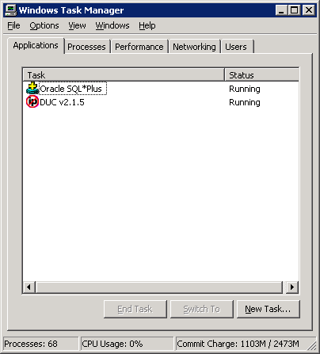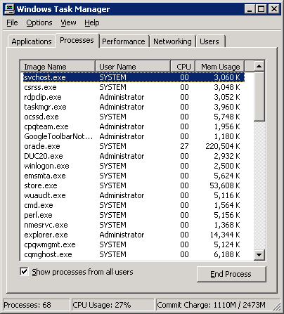
Application View Process View
Notice there are only 2 applications but 68 processes.

Threads
Think of a thread as a mini-process. If a process is a unit of work, then a thread is a smaller unit of work under the control of a process. The advantage of using threads is that a process can achieve a higher level of performance by creating many smaller units of work that can be executed in concurrently. Since the threads are being managed by the process the operating system can get more work done, since it doesn’t have the overhead of a Process Control Block for each thread. Therefore threads don’t require the operating system to manage memory, files, or deal with inter-thread synchronization.

Threads are commonly used by event-driven programs where there is no single program flow, just many different unrelated logic flows design to handle a variety of different events. Microsoft’s Office applications like Word or Excel and a database management system, like Oracle, are classic example of where you might find many threads being used.

4. CPU Scheduling
The in a multi-user environment, operating system needs a way to give each process an increment, or slice, of the CPU resource. CPU scheduling is a means for facilitating the optimization of the computer’s resources (CPU and I/O) by allowing multiple processes to execute concurrently.

CPU scheduling consists of two distinct components: the long-term scheduler and the dispatcher. The long-term scheduler manages the input of processes into the mix and is responsible for admitting them to the system. The dispatcher maintains the mix by providing short-term scheduling, i.e. instant-by-instant allocation of CPU for processes needing more CPU resources.

In modern operating systems there are algorithms used to determine when a process should be suspended and a new one put in its memory space. This operation is known as swapping.

5. Memory Management
Memory management is a way for assigning memory resources so that processes and data have the appropriate amount of memory for adequate loading and execution. For a multi-user system to be effective, each user’s processes need memory resources to be allocated equability. Memory is the first resource required before a process can be executed. So there is a strong correlation between the scheduling and memory management functions.

The amount of available memory limits the number of processes that can be scheduled and dispatched. Think of it this way, if there is only enough memory for one process, then a multi-user system effectively becomes a single-tasking system.

As a general rule the more processes that can be executed concurrently the better the overall computer system throughput – effectively the computer is doing more work during a given time interval. However, any one task or process may actually take longer in duration to complete then if it were executing in the system by itself.

6. Virtual Storage
In a multi-user system, an operating system creates an illusion that it has more “real” memory than is actually exists. Real memory is the amount of hardware memory contained on the memory cards plugged onto the motherboard. The computer I’m using has 1,000 megabytes of memory or approximately 1,000,000,000 eight-bit bytes for my Windows 2003 operating system to use. The good news is that with proper memory management using a technique called “paging”, the operating system can create what is called virtual memory by moving infrequently used processes (called pages) to disk and put in its real memory place a new process; thereby, creating an illusion that there is more memory than is really available. As processes become inactive, waiting for other resources such as I/O, the pages that were swapped to disk are brought back into real memory to be executed. To the user, it looks as though the system is capable of processing many more programs concurrently than there is real memory available to support them.

Virtual Machine
Virtualization is not a new concept. In fact virtual machines have been with since the late 1960’s. Some operating systems have the capability to create an environment that gives the illusion that a single computer looks to the user as if it were multiple computers, each with its own unique operating system. Operating systems with this capability are called “virtual machine” operating systems. Here the operating system provides the capability to run multiple operating systems as “guests” under the control of the “virtual machine” operating system. An example of this is IBM’s VM operating system. Under VM, the computer, a mainframe in this case, can run under VM a variety of different operating systems like Linux, MVS or zOS. These guest operating systems are tricked into believing that they have access to all the hardware resources: CPU, registers, memory and I/O, in essence they behave as separate machines; but in reality they are interfacing with VM on a single machine.
The downside to virtual machines is the amount of overhead required to support multiple operating systems. As computer hardware becomes more powerful, look to find this virtual machine capability become more popular.

7. Summary
Operating systems have become quite complex over the last several decades. They have gone from single user systems to multi-user, multi-tasking systems, from supporting few peripherals to supporting hundreds of peripherals, from supporting a single processor to supporting many processors. Operating system developers have designed into the operating system a set of sophisticated services that allow the computer system to manage itself. It does this quite remarkably considering the diversity of the many hardware resources contained in and attached to today’s modern computer systems.

